**תקשורת ומחשוב – תשפ"ב - סמס' א' - מטלה שלישית**

First of all we imported socket library in order to use all socket’s function. Then we set our PORT on which we will work. In our case: PORT = 65432. After that we used bind() to associate the socket with a specific network interface and port number. We put nothing in first and our PORT in second. And we used listen() to listen for connections from clients. When a client connects, the server calls accept() to accept, or complete, the connection. We put 1 to listen only for one client. serverSocket.accept() returns a new socket object representing the connection(in connectionSocket) and a tuple holding the address of the client(in addr). outputdata = f.read() – we just read the data from message. connectionSocket.send('\nHTTP/1.1 200 OK\n\n'.encode()) – return that it got the data.

connectionSocket.send("\nHTTP/1.1 404 Not Found\n\n".encode()) - return that it didn’t get the data.

connectionSocket.close() – close our socket connection between server and client.

There are some screenshots of our lab:

Our server in Chrome with HelloWord.html

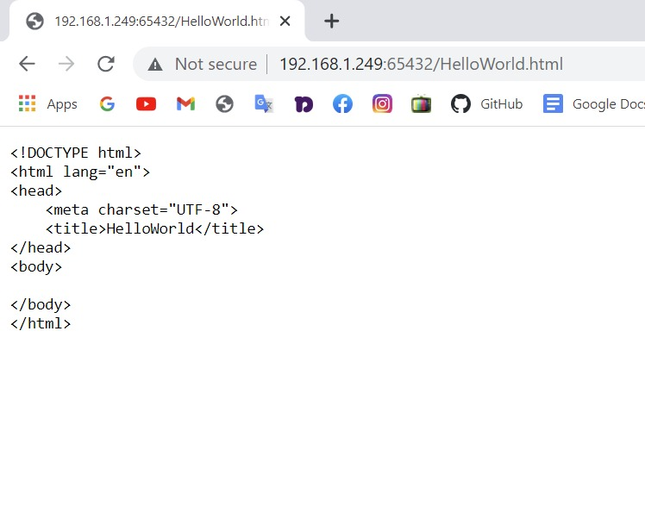

Also in PyCharm we got the HelooWord.html:

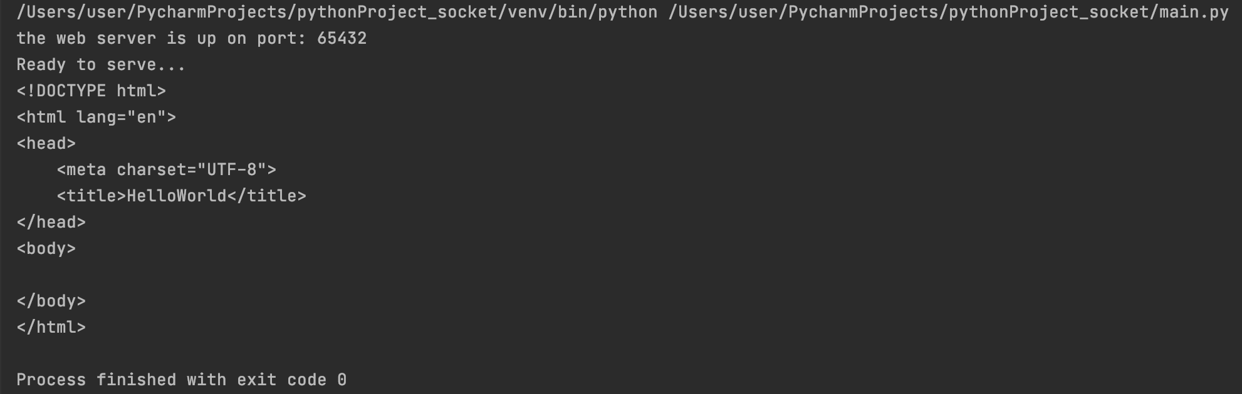

We get HTTP/1.1 200 OK from the line connectionSocket.send() of our code that socket is connected between server and client.

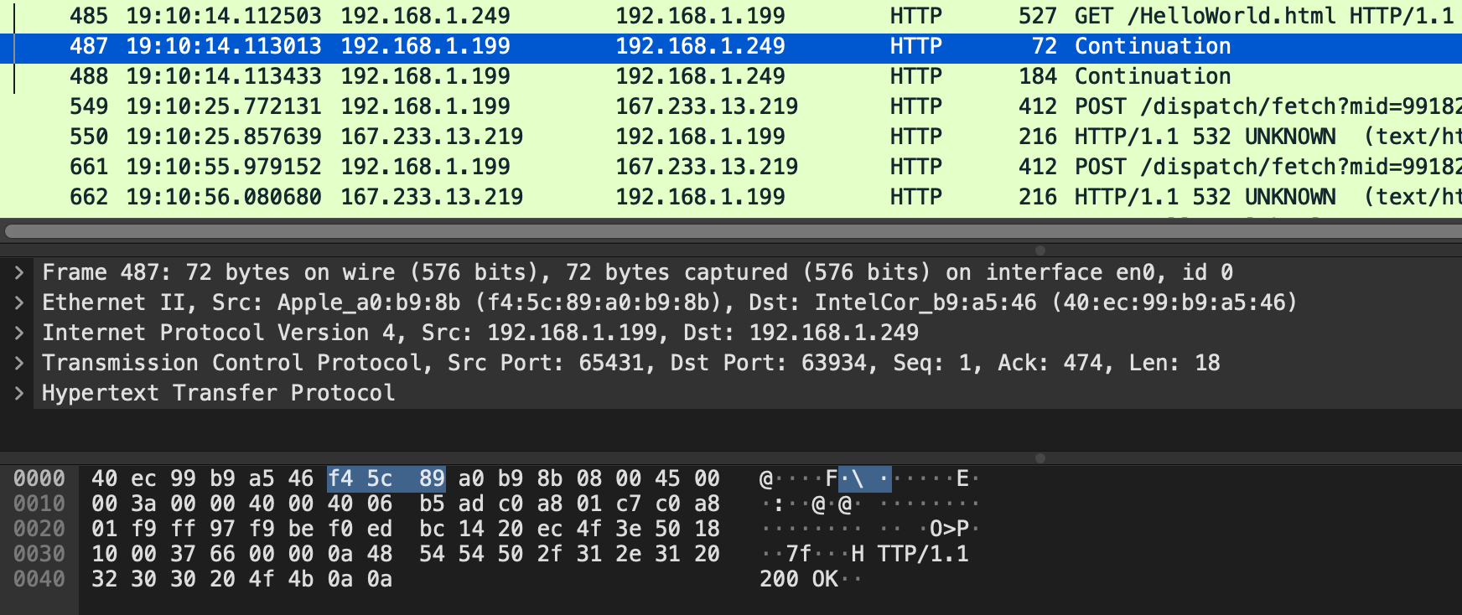

We get HTTP/1.1 404 Not Found from the line connectionSocket.send() of our code that file wasn’t found.

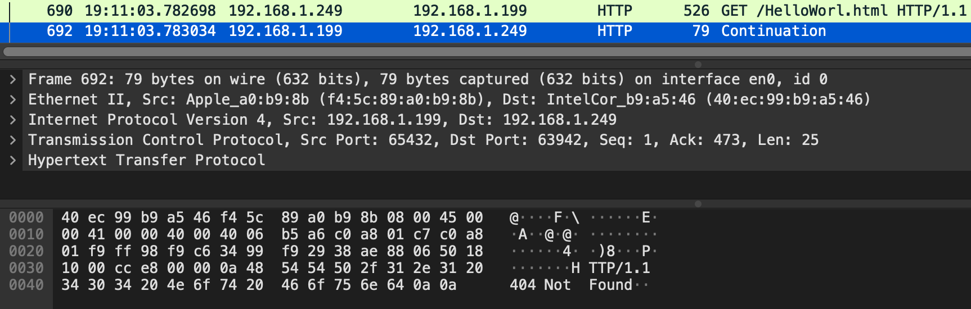

In the end we close our socket connection serverSocket.close()